COMP2511 meeting minutes

|  |  |
| --- | --- |
| Location: | Online |
| Date: | 5/7/2021 |
| Time: | 13:00 – 14:00 AEST |
| Attendees: | All |

# Agenda items

1. Discuss about whole game process
2. Discuss about the MVP backend and frontend
3. MVP plan and deadline

Outcomes

1. Process for menu and switch

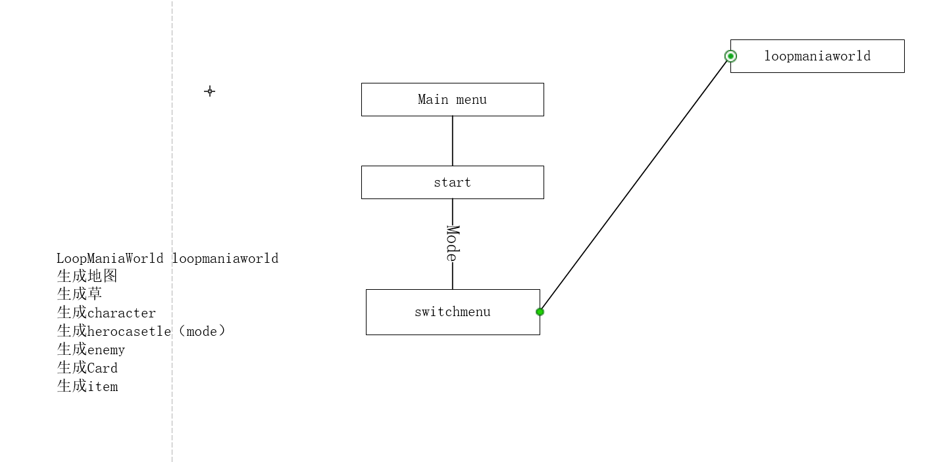

1. update the uml:  
   <https://app.diagrams.net/#G1RVFpE5RJj046vuzJ0czGAvqHGnGdPoVn>
2. Timer:  
   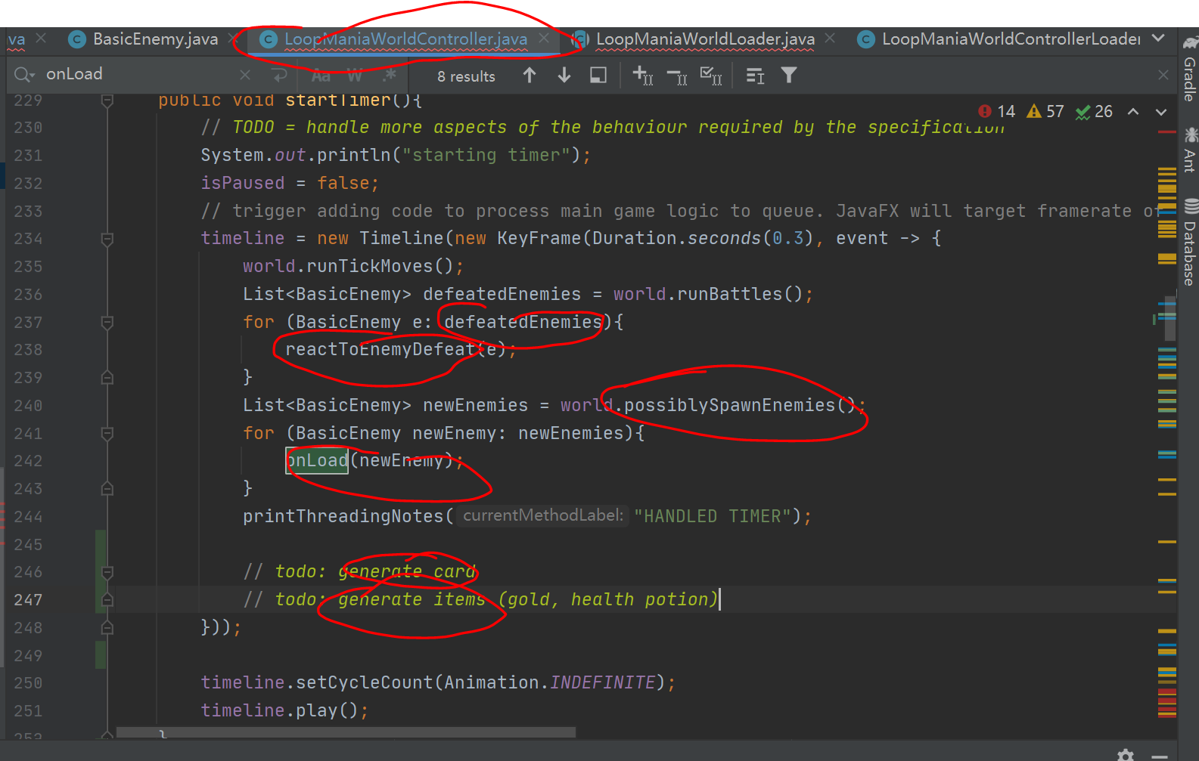

# Actions

|  |  |  |
| --- | --- | --- |
| Task | Allocation | Due date |
| Implement an MVP in the backend for items and cards | Suiyue Jiang | 6/7 Tuesday |
| Implement an MVP in the backend for characters and menu | Weiqiang Zhuang | 6/7 Tuesday |
| Implement an MVP in the backend for building and enemies | Wenyao Chen | 6/7 Tuesday |
| Implement an MVP in the frontend | Ao Dong | 8/7 Thursday |